SQL ASSIGNMENT -5

ROLL NO-84016

Q1.Write a query that will give you all orders for more than Rs1,000.
Ans.
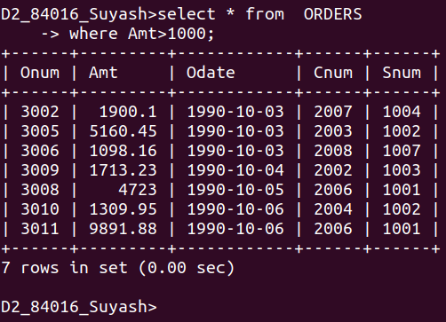

Q2.Write a query that will give you the names and cities of all salespeople in london with a commisson above .10 .
Ans.
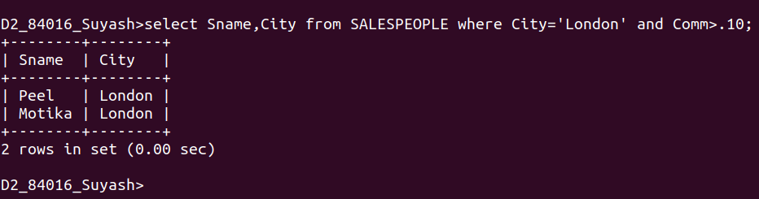

Q3.Write a query on customer table whose output will exclude all customers with a rating <=100,unless they are located in Rome.
Ans.
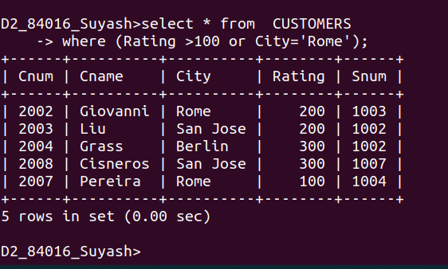

Q4.Write will be the output from the following query?
Select *from ORDERS
Where (amt<1000 Or NOT (Odate=’1990-10-03’ AND cnum>2003));
Ans:
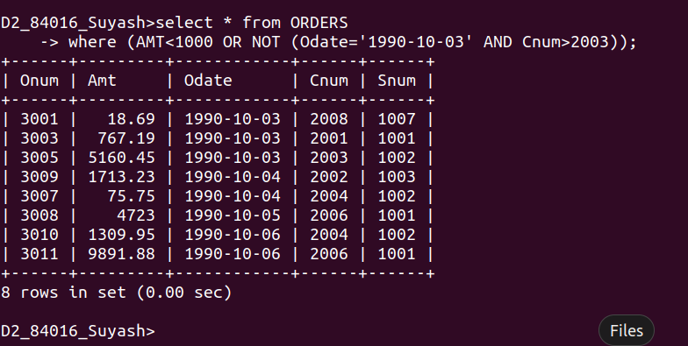

Q5.What will be the output of the following query?
Select * from ORDERS where NOT ((Odate=’1990-10-03’ OR Snum >1006) AND Amt>=1500);
Ans.

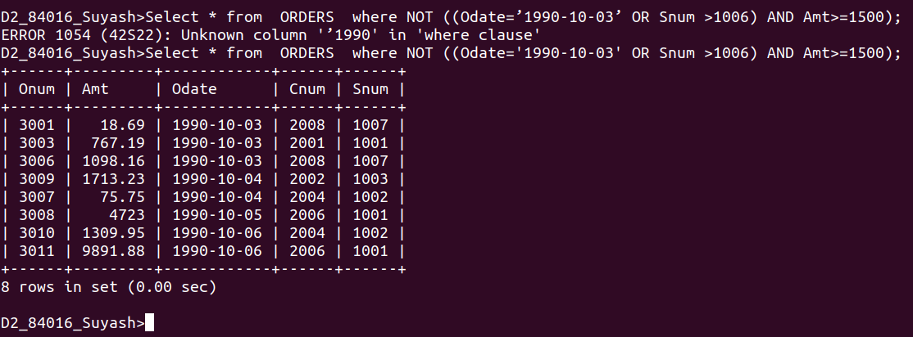
Q6. what is a simpler way to write this query?
Select Snum,Sname,City,Comm from SALESPEOPLE
where (Comm>.12 OR Comm<.14);
Ans.
